**R Code for Examples in the book**

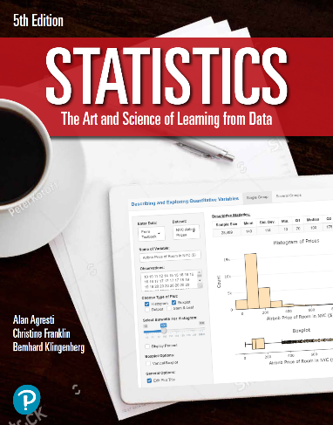

***“Statistics: The Art and Science of Learning from Data”***

**by Agresti, Franklin and Klingenberg, 5th edition**

**Chapter 8**

**Example 2: A Wife’s Career – Standard Error and Margin of Error**

## Reading in sample proportion data

n <- 1545  
phat <- 398 / n

## To compute the standard error

se <- sqrt(phat * (1 - phat) / n)  
se

## [1] 0.01112578

## To compute the margin of error for a confidence level of 95%

me <- 1.96 * se  
me

## [1] 0.02180653